Project Title
AI-Powered Waste Sorting and Suggestion System (SMART-RECYCLE)
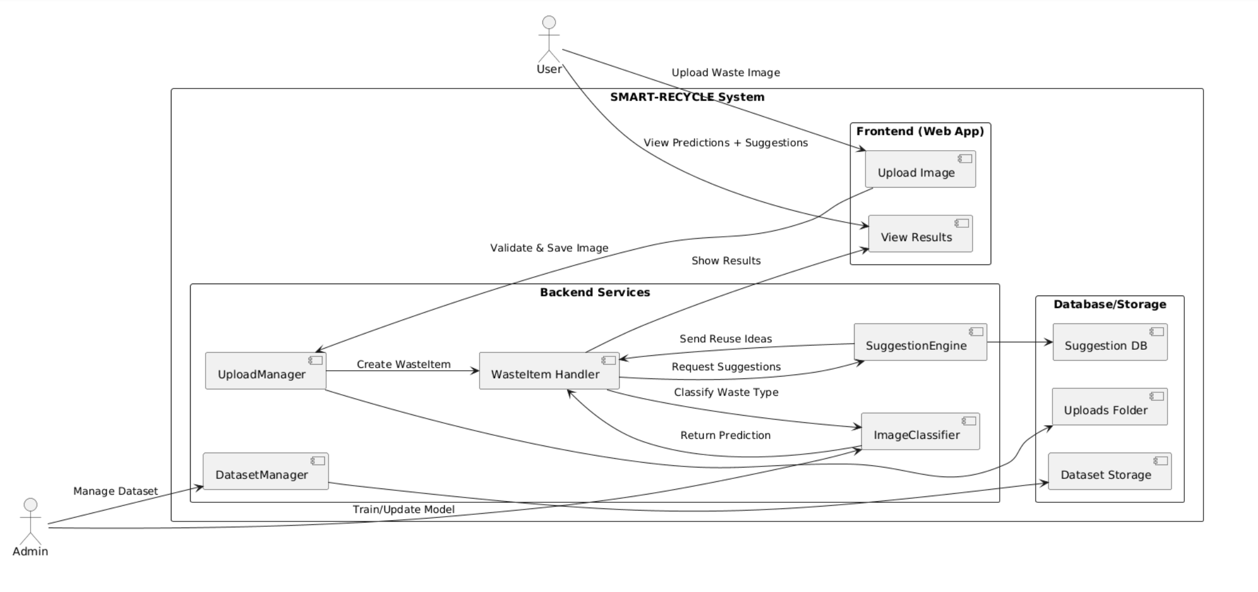
Project Objective For any other reference => Link to ChatGpt
Create a system that classifies waste materials into categories like plastic, paper, metal, cardboard, glass, and trash using image processing and convolutional neural networks (CNNs), thereby enhancing recycling efficiency.
The system will also provide recommendations and suggestions for reusing/upcycling the detected waste into useful products.
System Overview
- User uploads an image of waste material.
- System preprocesses the image → CNN model predicts the category.
- Based on the predicted class, a Suggestion Engine provides creative reuse ideas, tutorials, and safety guidelines.
- Users can provide feedback (helpful/not helpful, comments).
- Admin can manage dataset, retrain model, and update suggestions.
Project Breakdown – Step-by-Step
1. Dataset Collection
Waste categories: plastic, paper, metal, cardboard, glass, trash
References:
- GitHub: https://github.com/garythung/trashnet
- HuggingFace: https://huggingface.co/datasets/garythung/trashnet
- Kaggle_1: https://www.kaggle.com/datasets/asdasdasasdas/garbage-classification
- Kaggle_2: https://www.kaggle.com/datasets/kneroma/tacotrashdataset
- Kaggle_3: https://www.kaggle.com/datasets/techsash/waste-classification-data

- Google Drive (TrashNet mirror): https://drive.google.com/drive/folders/1CTvT_gnTvwlcKwJ8yz4jUOs0JYTKrplA
- Research Paper: https://cs229.stanford.edu/proj2016/report/ThungYang-ClassificationOfTrashForRecyclabilityStatus-report.pdf
2. Data Preprocessing
- Resize images (128×128 or 150×150)
- Labeling (plastic, paper, metal, cardboard, glass, trash)
- Augmentation: rotation, flip, zoom, brightness jitter
- Normalize pixel values (0–255 → 0–1)
- Train/Validation/Test split: 70:15:15
- Store metadata: {filename, label, source, resolution, date}
3. Model Architecture
- Baseline: Custom CNN (Conv2D + MaxPool + Dense)
- Optimized: Transfer learning with MobileNetV2 / ResNet50 (fine-tuned)
- Loss Function: categorical_crossentropy
- Optimizer: Adam (lr=0.001)
- Metrics: Accuracy, Precision, Recall, F1-score
4. Model Evaluation
- Accuracy
- Confusion Matrix
- Per-class Precision/Recall
- Error Analysis
- Model versioning with metadata file (model_meta.json)
5. Recommendation & Suggestion Engine
- Rule-based (JSON mapping):
Example:
- {
- "plastic": ["Make a plant pot", "DIY bird feeder", "Desk organizer"]
- }
- Tutorial links for each suggestion (YouTube/Instructables).
- Safety notes (e.g., wash bottles, avoid rust).
- Future upgrade: ML-based personalized recommender.
6. Feedback Loop
- Users can rate suggestions (👍/👎) and add comments.
- Feedback stored in DB (feedback collection).
- Admin can retrain model and refine suggestions.

7. Frontend + Backend Integration
- Frontend: HTML, CSS, JavaScript
- Backend: Flask (or Node.js + Express)
- Model Serving: Flask → tensorflow.keras.models.load_model
- Endpoints:
  - POST /api/upload → Upload image
  - GET /api/predict/<upload_id> → Get predicted class + confidence
  - GET /api/suggestions/<class> → Fetch reuse ideas
  - POST /api/feedback → Store feedback
  - POST /admin/train → Retrain model (admin only)

8. Deployment
- Containerized with Docker + docker-compose
- Hosted on Render / AWS / Heroku
- Web server: Nginx + Gunicorn
- Optional: TensorFlow-Serving for scalable inference

9. Security & Privacy
- File type validation (JPEG/PNG only)
- Max upload size limit
- HTTPS enforced
- Admin endpoints protected with JWT authentication
- Option to auto-delete user uploads after processing

10. Non-Functional Requirements
- Performance: Prediction latency < 2s
- Scalability: Support 100+ concurrent users (Docker + autoscaling)
- Usability: Simple, mobile-responsive UI
- Reliability: Graceful fallback if model/API unavailable

11. Testing Plan
- Unit Tests: preprocessing, API routes, suggestion fetcher
- Integration Tests: upload → predict → suggestions → feedback flow
- Model Tests: Ensure accuracy doesn’t drop after retraining
- User Testing: Real users test suggestions usability

12. Admin Features
- Dataset Manager: Upload/remove images, correct labels
- Model Trainer: Trigger retraining, view logs
- Suggestions Manager: Add/edit/delete ideas
- Analytics Dashboard: Usage metrics, top suggestions, misclassifications

13. Future Enhancements
- Real-time video waste classification
- Mobile app (React Native / Flutter)
- Integration with IoT Smart Bins
- Marketplace for upcycled products
- GPT-powered suggestion engine for creative ideas
Short Flow (Summary)
- Image Processing: Python, TensorFlow, NumPy
- Model Training: TensorFlow/Keras
- Web App: Flask + HTML/CSS/JS
- Suggestion Engine: Rule-based JSON mapping
- Deployment: Docker + Render/AWS

USE Case diagram:
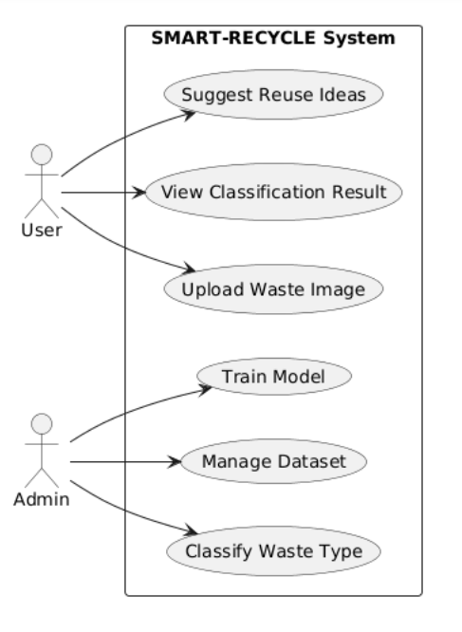
Activity Diagram:
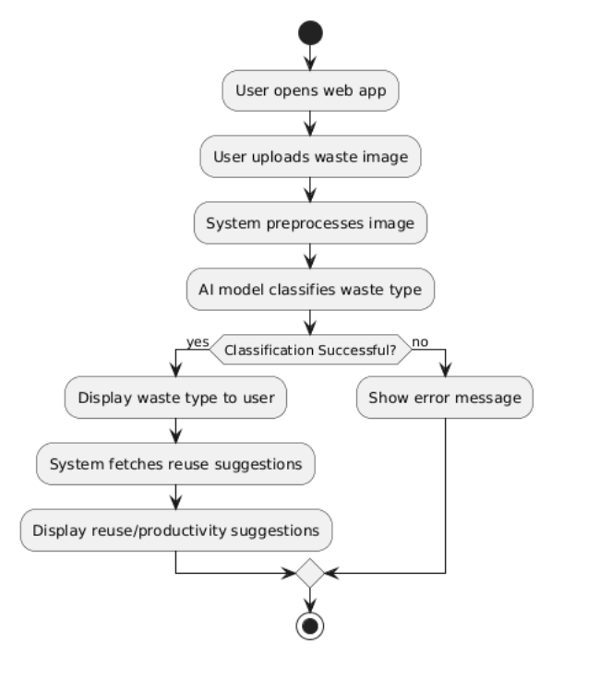

Class Diagram:
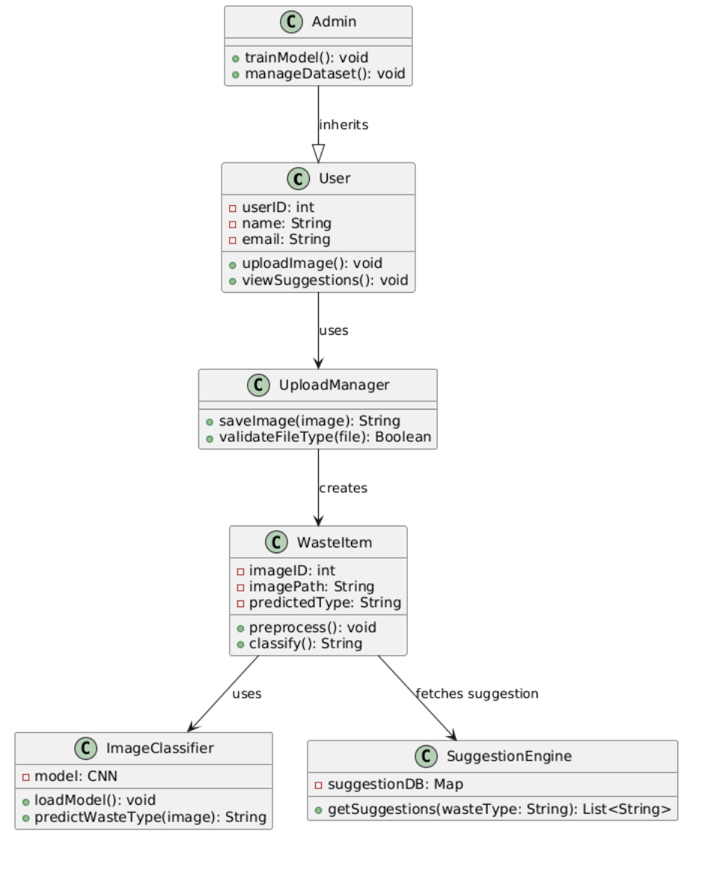

Sequence Diagram:
Scenario 1: Waste Image Upload & Classification
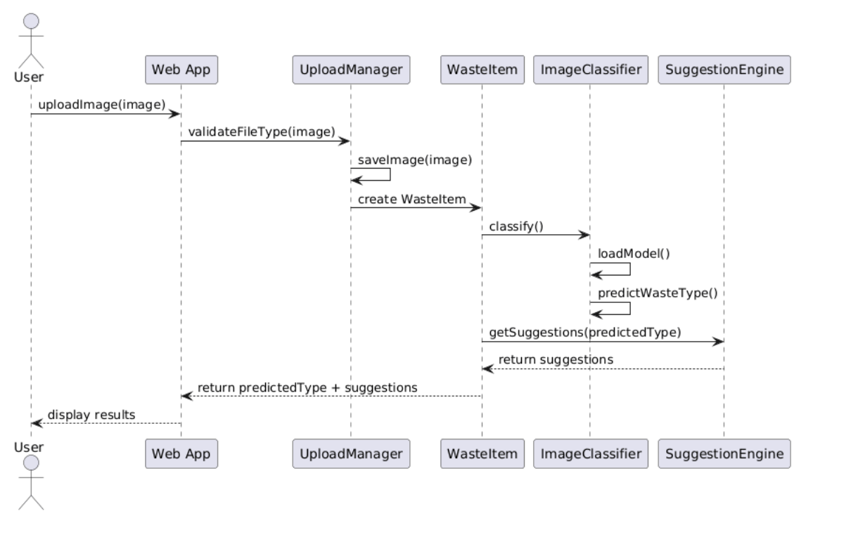
Scenario 2: Admin Trains the Model and Updates Dataset
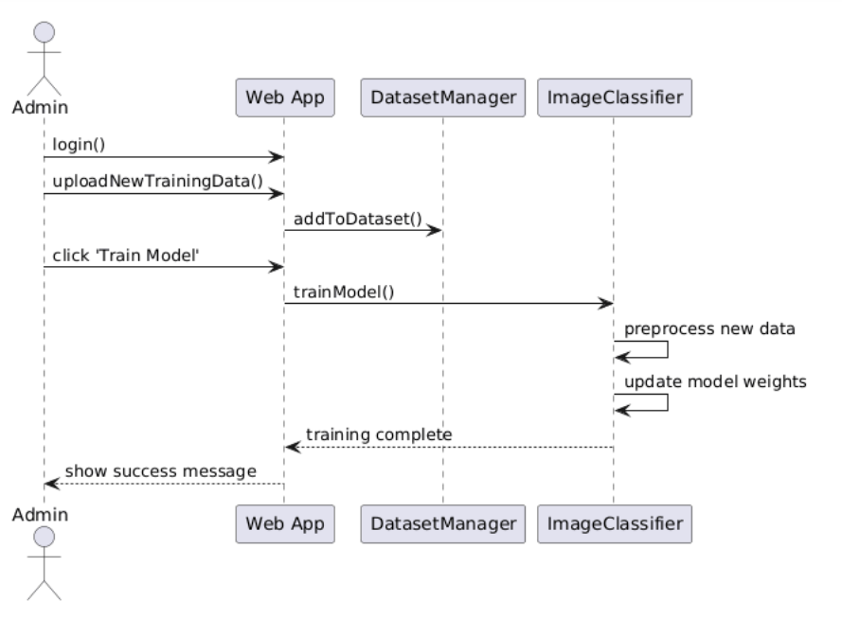

Complete Component Diagram:


